Defect Management

**Defect Management (DM)**is the process of logging, tracking and closing all the defects that are identified during the course of STLC.

Defect management processes and responsibilities are defined based on the life cycle of a defect.

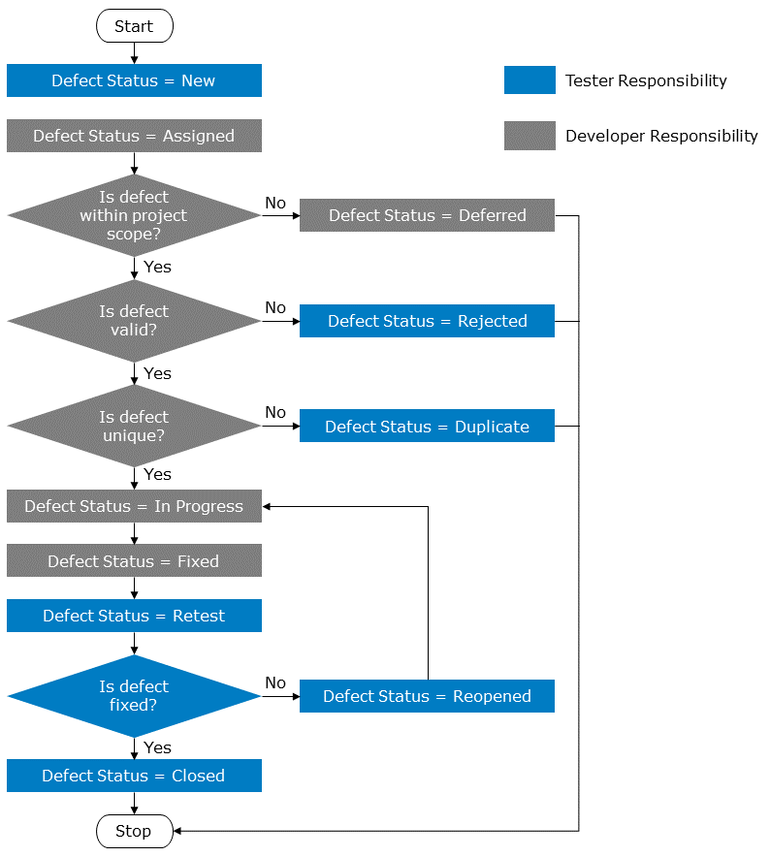

| **Defect Status** | **Description** |
| --- | --- |
| New | New defect identified by the tester. |
| Assigned | Defect assigned to a specific developer for analysis and fixing. |
| Deferred | Defect found to be our of current project scope after developer's analysis. Will not be fixed for the current release cycle. A decision needs to be taken by all stakeholders on which future release this defect should be addressed. |
| Rejected | Defect not found to be valid as per the requirements after developer's analysis. Hence rejected and sent back to tester who raised it. |
| Duplicate | Developer found to be a duplicate of an already existing defect after developer's analysis. This defect would not be addressed as the original defect is already being worked on. |
| In Progress | After analysis the developer has accepted the defect and is currently working on the fix. |
| Fixed | The defect has been fixed and it will be available to the tester in the upcoming build deployment. |
| Retest | The defect fix has been deployed in the test environment by  the developer. The tester can go ahead with the defect retest. |
| Reopen | The tester has completed the retest and the defect fix is not working as expected. The developer needs to look into it further. |
| Closed | The tester has completed the retest and confirmed that the defect fix has resolved the defect. |